# TITLE PAGE

**A Model Architecture for Staff Promotion and Renumeration Management System**

**BY**

**JOSEPH EMMANUEL**

**ST/CS/ND/21/015**

**DEPARTMENT OF COMPUTER SCIENCE,**

**SCHOOL OF SCIENCE AND TECHNOLOGY,**

**FEDERAL POLYTECHNIC, MUBI, ADAMAWA STATE.**

**IN PARTIAL FULFILLMENT OF THE REQUIREMENT FOR THE AWARD OF NATIONAL DIPLOMA (ND) IN COMPUTER SCIENCE.**

**SEPTEMBER, 2023**

# DECLARATION

I hereby declare that the work in this project titled **“A Model Architecture for Staff Promotion and Renumeration Management System”** was performed by me under the supervision of Mal. Mustapha Garba Sintali. The information derived from literatures has been duly acknowledged in the text and a list of references provided. The work embodied in this project is original and had not been submitted in part or in full for any other diploma or certificate of this or any other institution.

JOSEPH EMMANUEL ________________ _______________

(ST/CS/ND/21/015) Signature Date

# CERTIFICATION

This project titled **“A Model Architecture for Staff Promotion and Renumeration Management System”** meets the regulations governing the award of National Diploma (ND) in Computer Science, Federal Polytechnic Mubi, Adamawa State

Mal. Mustapha Garba Sintali __________________

(Project Supervisor) Sign/Date

Mr. Mustapha Kassim __________________

(Head of Department) Sign/Date

Mal. Abdulrahman Saidu _________________

(External Examiner) Sign/Date

# DEDICATION

This project is dedicated to my beloved parents for their advice, encouragement and financial support towards my academic pursuit.

# ACKNOWLEDGEMENTS

I want to acknowledge Almighty God for his infinite mercy and protection throughout my academic activities. And for the understanding in achieving our academic success.

I also recognize my Supervisor Mal. Mustapha Garba Sintali, who took time, despite her busy schedule to directed and guided me throughout this research work.

I also acknowledge the Head of Department Computer Science Mr. Mustapha Kassim for his moral encouragement throughout my period of study. I also acknowledge all Staff of Computer Science Department for their support and encouragement and the knowledge they’ve impacted on me throughout our studies.

I also want to appreciate our parents for their love and care and for giving me the opportunity to be trained and achieve our dreams.

Finally, I appreciate the efforts of my Uncles and aunties, for their encouragement and support throughout the course of our study and also our friends and relatives, course mates and all well-wishers. I love you all, may the Almighty God bless you abundantly, Amen.

# TABLE OF CONTENTS

TITLE PAGE i

DECLARATION ii

CERTIFICATION iii

DEDICATION iv

ACKNOWLEDGEMENTS v

LIST OF FIGURES viii

LIST OF TABLES ix

ABSTRACT x

CHAPTER ONE 1

INTRODUCTION 1

1.1 Background to the Study 1

1.2 Problem Statement 2

1.3 Aim and Objectives 3

1.4 Significance of the Study 3

1.5 Scope of the Study 4

1.6 Definition of Some Operational Terms 5

CHAPTER TWO 6

LITERATURE REVIEW 6

2.1 Introduction 6

2.2 Staff Promotion System 6

2.3 Remuneration Management System 7

2.3.1 Key Concepts of Renumerations 7

2.3.2 Recent Trends in Remuneration Management Systems: 8

2.4 Management Information System 9

2.5 Record Management System 10

2.6 Database Management System 11

CHAPTER THREE 12

SYSTEM ANALYSIS AND DESIGN 12

3.1 Introduction 12

3.2 Disadvantages of the Existing System 12

3.3 Advantages of the Proposed System 12

3.4 The Proposed Method 13

3.5 Method of Data Collection 14

3.6 System Design 15

3.6.1 Algorithm Diagram 15

3.6.2 System Architecture 16

3.6.3 Database Tables/Queries Structures 16

3.6.4 Database Entity Relationship Diagram 18

3.6.5 The Input and Output Design 18

3.7 System Requirement Specification 21

3.7.1 Hardware Requirements 21

3.7.2 Software Requirements 21

3.7.3 Personnel Requirements 21

CHAPTER FOUR 22

RESULTS AND DISCUSSION 22

4.1 Introduction 22

4.2 Results 22

4.2.1 Welcome Interface 22

4.2.2 Login Interface 22

4.2.3 Registration Interface 23

4.2.4 Apply for Promotion 23

4.2.5 Promotion Request 24

4.2.6 Create New Department 24

4.2.7 Create New Level 25

4.2.8 Dashboard Interface 25

4.3 Discussion 26

4.4 User manual 27

CHAPTER FIVE 28

SUMMARY, CONCLUSION AND RECOMMENDATIONS 28

5.1 Summary 28

5.2 Conclusion 28

5.3 Recommendations 28

5.4 Contribution to Knowledge 28

5.5 Area for Further Work 28

REFERENCES 29  
APPENDICES 32

# LIST OF FIGURES

Figure 3.1: Waterfall Model - - - - - - - - 14

Figure 3.2: Use Case Diagram - - - - - - - 15

Figure 3.3: System Architecture - - - - - - 16

Figure 3.4: Database Entity Relationship Diagram - - - - - 18

Figure 3.5: Login interface - - - - - - - - 18

Figure 3.6: Registration Interface - - - - - - - 19

Figure 3.7: Apply for Promotion Interface - - - - - - 19

Figure 3.8: Add Department - - - - - - - - 20

Figure 3.9: Add Level - - - - - - - - - 20

Figure 4.2.1: Welcome Interface - - - - - - - 22

Figure 4.2.2: Login page interface - - - - - - - 22

Figure 4.2.3: Registration Interface - - - - - - - 23

Figure 4.2.4: Apply for Promotion Interface - - - - - - 23

Figure 4.2.5: Promotion Request Interface - - - - - - 24

Figure 4.2.6: Create New Department - - - - - - 24

Figure 4.2.7: Create Level Interface - - - - - - - 25

Figure 4.2.8: Dashboard Interface - - - - - - - 25

# LIST OF TABLES

Table 3.1: **Users Table** - - - - - - - - - 16

Table 3.2: **Departments Table** - - - - - - - - 17

Table 3.3: **Designation Table** - - - - - - - - 17

Table 3.4: **Promotion Table** - - - - - - - - 17

# ****ABSTRACT****

***In today's dynamic organizational landscape, the effective management of staff promotion and remuneration processes plays a pivotal role in fostering a motivated workforce and achieving sustainable growth. This study introduces a comprehensive Model Architecture designed to revolutionize the way organizations approach staff promotion and remuneration. The primary objective of this model architecture is to establish a systematic, transparent, and data-driven approach to staff promotion and remuneration management. By leveraging advanced technologies and strategic frameworks, the architecture aims to streamline decision-making processes, enhance fairness, and optimize resource allocation. The core components of the model architecture encompass the automation of promotion evaluation, the integration of performance metrics, experience-based remuneration adjustments, and the implementation of robust security measures. These components collectively contribute to the overarching goal of cultivating an environment of meritocracy, where promotions and remuneration are intricately linked to individual contributions and organizational goals. Transparency and accountability are paramount within this architecture. A user-friendly interface grants employees’ insight into their promotion pathways and remuneration structures, fostering a sense of empowerment and engagement. Simultaneously, management gains access to comprehensive data analytics that inform strategic decisions and ensure alignment with market trends. Ultimately, this Model Architecture for Staff Promotion and Remuneration Management System represents a significant leap forward in transforming traditional practices. Its innovative approach aligns with modern organizational demands, enhancing efficiency, equity, and employee satisfaction. As organizations navigate the complexities of talent management, this architecture stands poised to shape a new paradigm in staff promotion and remuneration strategies.***

# CHAPTER ONE

# INTRODUCTION

## 1.1 Background to the Study

In today's rapidly evolving business landscape, effective management of human resources is crucial for organizational success. Staff promotion and remuneration play pivotal roles in retaining talent and maintaining employee motivation. As organizations grow, managing staff promotions and remuneration becomes increasingly complex, necessitating sophisticated technological solutions. In the contemporary corporate landscape, effective human resource management is a cornerstone of organizational success (Goblar 2022).

Staff promotion is the advancement of an employee's rank or position in an organizational hierarchy system. Kalesh and Tuwei (2022), stated further that, promotion may be an employee's reward for good performance and that is a positive appraisal. Also, before an employer promotes an employee to a particular upward position it ensures that the person is able to handle the added responsibilities and other duties by screening the employee with interviews, tests and giving them more training off-the-job or on-the job experience. According to Kalesh and Tuwei (2022), wrote, promotion can involve advancement in terms of designation, salary and benefits, and in some organizations the type of job activities may change a greatly, meaning more decision-making tasks.

Staff promotion and remuneration are pivotal aspects of this management, directly impacting employee motivation, engagement, and overall performance. Organizations across industries strive to optimize these processes to ensure employee retention, job satisfaction, and competitiveness. However, the traditional manual and semi-automated methods of managing staff promotion and remuneration have proven to be inadequate in addressing the complexities of today's dynamic workforce. In recent years, technological advancements and the proliferation of data-driven decision-making have prompted organizations to rethink their approaches to HR management. The integration of modern technologies such as machine learning, data analytics, and artificial intelligence has shown great potential in transforming HR practices, making them more accurate, efficient, and responsive to organizational needs (Mahmud, 2020).

According to a study by Deloitte (2017), companies are increasingly adopting digital HR tools to streamline their HR processes, with 57% of organizations considering AI and analytics as important for their HR strategies. In the realm of staff promotion and remuneration, the implementation of advanced technologies can mitigate biases, improve transparency, and enable data-driven decision-making, thereby enhancing the overall fairness and effectiveness of these processes. The complexity of modern organizations, with diverse job roles, skill sets, and hierarchical structures, demands a comprehensive solution that can adapt to these intricate dynamics. A model architecture that leverages data-driven insights can provide a structured approach to addressing the challenges inherent in staff promotion and remuneration management. This architecture would not only automate and streamline the processes but also facilitate informed decisions that align with an organization's goals and values.

In this context, the development of a robust model architecture tailored to the unique challenges of staff promotion and remuneration management is an imperative. Such an architecture could incorporate predictive analytics to identify high-potential employees, ensure fair and consistent evaluation criteria, and align compensation with performance. Additionally, a well-designed architecture could enhance transparency by providing employees with clear insights into the factors influencing their career progression and compensation. In any organization, there is existence of a system that manages its staff information effectively. This brings the need to develop a database that stores and retrieve relevant information of a staff. In the development of the management system, the storing of data of the organizational staffs is prioritized. The database management which controls the creation and maintenance of records together with the leave and attendance management provides efficient and flexible way to manage the organization’s personnel information. The combination of these modules into one application assures the perfect platform for aligning Human resources processes in the organization (Gartner, 2019).

Normally, the companies and institutes either inside the government system or inside the private section aim to find out a new approach for satisfying their requirement in economy and efficient way. This is the main reason behind adopting the electronic applications in terms of website and windows. Human Resources Management System is one of the important parts in the electronic approach that uses web applications designed using (PHP, MySQL, JavaScript, HTML, and CSS). HRMS could be used in institutions and companies to organize and arrange the personnel files as well as the managing and organizing of the employees' salaries and undergone updates during the year. The HR systems have been considered previously in various research projects because of its substantial role and important (Wasnaa, 2020).

## 1.2 Problem Statement

1. The traditional manual and semi-automated methods of staff promotion and remuneration management are fraught with issues of bias, subjectivity, and inefficiency.
2. These methods struggle to adapt to the complexities of the contemporary workforce and often result in inconsistencies that impact employee morale, engagement, and overall organizational performance.
3. Lack of transparency in these processes raises concerns about fairness and equity, further eroding employee trust. As organizations strive to leverage advanced technologies and data-driven decision-making in HR practices, there is a critical need for a model architecture that addresses these challenges, optimizes staff promotion and remuneration, and ensures fairness, transparency, and alignment with organizational goals.

Developing such an architecture will lead to enhanced employee satisfaction, improved organizational performance, and a more inclusive work environment. This research aims to develop a model architecture that addresses these challenges and streamlines the staff promotion and remuneration processes.

## 1.3 Aim and Objectives

The aim of this project is to develop a Model Architecture for Staff Promotion and Renumeration Management System. The specific objectives are:

1. To design a model architecture for an automated Staff Promotion and Remuneration Management System (SPRMS).
2. To enhance accuracy and fairness in the staff promotion process through data-driven decision-making.
3. To optimize remuneration management based on performance, experience, and market trends.
4. To ensure transparency, security, and accountability in the promotion and remuneration processes.

## 1.4 Significance of the Study

The significance of developing a model architecture for Staff Promotion and Remuneration Management System (SPRMS) extends beyond the immediate operational improvements.

Improved Employee Satisfaction and Motivation: An automated and data-driven SPRMS can ensure that promotion and remuneration decisions are based on objective criteria, reducing biases and favoritism. This fosters a sense of fairness and equity among employees, leading to higher levels of job satisfaction and motivation.

Enhanced Organizational Performance: When employees perceive that promotion and compensation are tied to their contributions and skills, they are more likely to invest greater effort into their roles. This, in turn, can lead to improved job performance, increased productivity, and overall organizational success.

Reduced Administrative Burden: Automation of promotion and remuneration processes can significantly reduce the administrative workload for HR personnel. This allows HR teams to focus on strategic initiatives, talent development, and employee engagement activities that contribute to long-term organizational growth.

Informed Decision-Making: Data-driven insights from the SPRMS can facilitate informed decision-making at both the individual and organizational levels. Managers can better understand employee performance trends, skill gaps, and potential areas for improvement, enabling them to make more effective decisions.

Mitigated Biases and Diversity Enhancement: By minimizing subjectivity in promotion and remuneration decisions, the SPRMS can help organizations address diversity and inclusion challenges. It can identify potential biases and discrepancies, ensuring fair treatment for all employees regardless of gender, ethnicity, or other factors.

Alignment with Modern Workforce Dynamics: The SPRMS can adapt to changing workforce dynamics, including evolving job roles, remote work arrangements, and flexible career paths. This adaptability ensures that the organization remains competitive in attracting and retaining top talent.

## 1.5 Scope of the Study

The scope of this research encompasses the design and development of a model architecture for the Staff Promotion and Remuneration Management System. The architecture will leverage cutting-edge technologies such as machine learning, data analytics, and AI to address the challenges associated with staff promotion and remuneration. However, the research will not delve into the detailed implementation of the system on a specific technology stack or platform.

The model architecture will be tailored to accommodate the specific needs of different industries, organizational sizes, and structures. It will provide a framework for automating promotion and remuneration decisions, incorporating performance metrics, skill assessments, and market trends. Additionally, the architecture will emphasize transparency, accountability, and fairness to ensure employee trust in the system. The research will also discuss the ethical considerations and potential challenges associated with implementing such a system, such as data privacy, algorithmic bias, and change management. However, the practical implementation and integration of the proposed architecture into an organization's existing IT infrastructure will be beyond the scope of this study.

By focusing on the design and theoretical aspects of the SPRMS architecture, this research aims to lay the foundation for future practical implementations and provide valuable insights for organizations seeking to modernize their staff promotion and remuneration processes.

## 1.6 Definition of Some Operational Terms

**Staff Promotion:** The process of advancing employees to higher-level positions within an organization based on their performance, skills, and potential for growth

**Remuneration Management:** The systematic planning, implementation, and monitoring of compensation strategies and structures to ensure fair and competitive pay for employees in alignment with organizational goals

**Model Architecture:** A structured framework that outlines the design, components, and interactions of a system, which in this case refers to the architecture of the proposed Staff Promotion and Remuneration Management System (SPRMS)

**Data-driven Decision-Making:** The process of making informed and strategic decisions based on the analysis and interpretation of data and relevant information

**Bias:** The presence of systematic and disproportionate influence in decision-making that leads to unfair or inaccurate outcomes

**Transparency:** The quality of a process or system that is open, clear, and easily understandable, allowing stakeholders to comprehend the rationale and mechanisms behind decisions

**Fairness:** The equitable treatment of individuals without bias or discrimination, ensuring that decisions and actions are just and impartial

**Automation**: The use of technology and software to execute tasks or processes with minimal human intervention, enhancing efficiency and reducing errors

# CHAPTER TWO

# LITERATURE REVIEW

## 2.1 Introduction

This chapter provides an overview of the relevant literature on staff promotion, remuneration management, and existing information systems in HR. The review of existing studies and research aims to establish the context and theoretical foundation for the development of the proposed model architecture for Staff Promotion and Remuneration Management System (SPRMS).

## 2.2 Staff Promotion System

Employee promotions are a critical aspect of organizational development, impacting employee motivation, performance, and retention. Extensive research has focused on various dimensions of staff promotion systems, including their impact on employee morale, organizational culture, and overall productivity. Early research by Lazear and Rosen (2018), highlighted the role of productivity and skills as primary determinants of employee promotion. This foundational study emphasized the importance of aligning promotion decisions with an employee's contributions to the organization. Recent studies by Allen & James (2021), further underscored the significance of considering both performance and potential when making promotion decisions.

The fairness and transparency of promotion processes have received considerable attention. A study by Cable and Judge (2016), emphasized the psychological impact of perceived fairness on employee satisfaction and commitment. Modern research by Anderson and Schalk (2018), highlighted that transparent promotion criteria contribute to reducing perceptions of bias and enhancing organizational trust.

Diversity and inclusion have gained prominence in recent promotion system literature. Studies by Shore (2019) and Bendl (2021), emphasized the need for organizations to create equitable promotion systems that consider gender, ethnicity, and other demographic factors. These studies highlighted the positive impact of diverse leadership teams on overall organizational performance. Performance evaluation is a central aspect of promotion systems. Early work by Tziner and Vardi (2018), emphasized the importance of accurate and reliable performance metrics in determining promotions. Recent studies by DeNisi and Kluger (2020), highlighted the value of ongoing feedback and coaching in enhancing employee performance, ultimately influencing promotion prospects.

Research by Wayne (2022), highlighted the importance of employee development programs in fostering skill acquisition and preparing employees for higher-level roles. Organizations that invest in training, mentoring, and skill development are more likely to have a robust pool of candidates for promotion. Recent literature has explored the concept of skill-based promotions as an alternative to traditional tenure-based systems. Ilmakunnas (2023), advocated for recognizing and rewarding employees based on the skills they acquire, leading to more dynamic and adaptable promotion structures. The rise of technology has impacted promotion systems. Research by Aguinis and Kraiger (2019), explored how technology can facilitate data-driven promotion decisions, enabling organizations to make more accurate and objective assessments of employee performance.

## 2.3 Remuneration Management System

Remuneration management systems encompass a comprehensive approach to designing, implementing, and administering compensation structures within organizations. These systems are pivotal in attracting and retaining talent, enhancing employee motivation, and aligning individual and organizational goals. This expanded literature review delves deeper into the concept of remuneration management systems, explores recent trends, and examines the significance of strategic alignment and employee engagement.

Remuneration, or compensation, is a crucial aspect of the employment relationship, impacting job satisfaction, motivation, and overall organizational performance. The design and implementation of effective remuneration systems are essential for attracting, retaining, and motivating employees while aligning their efforts with the organization's goals. Effective remuneration systems play a pivotal role in organizational success by attracting, retaining, and motivating employees. The integration of various theoretical frameworks and the adaptation of emerging trends in compensation strategies contribute to the development of comprehensive and impactful remuneration systems. Organizations must carefully consider their unique needs and goals while designing and implementing these systems to create a motivated and engaged workforce. This literature review aims to explore key concepts, trends, and approaches in remuneration systems.

## 2.3.1 Key Concepts of Renumerations

Equity Theory: Equity theory, proposed by Adams (2022), suggests that individuals evaluate their compensation in relation to their inputs (effort, skills) and compare it to the outcomes (rewards) they receive. If perceived inequity exists, employees may become demotivated.

Expectancy Theory: Vroom's expectancy theory (2017), asserts that employees will be motivated to perform better if they believe that their efforts will lead to desirable rewards, such as higher remuneration.

Total Rewards: Remuneration systems encompass not only monetary compensation but also non-monetary rewards like recognition, work-life balance, and career development. The "total rewards" approach considers both tangible and intangible elements of compensation.

## 2.3.2 Recent Trends in Remuneration Management Systems:

Digitalization and Automation: The integration of technology in remuneration management has streamlined processes, enabled accurate data analysis, and facilitated real-time tracking of compensation metrics. Automation tools assist in administering various compensation components, ensuring efficiency and reducing errors (Kapoor & Singh, 2020).

Personalization and Customization: Organizations are moving towards personalized compensation structures that consider individual preferences and needs. Customization of benefits and rewards enhances employee satisfaction and demonstrates a commitment to employee well-being (Reddy & Kumar, 2021).

Employee Well-Being and Total Rewards: Beyond financial compensation, organizations are focusing on holistic well-being through comprehensive total rewards packages. This approach includes physical, mental, and financial wellness programs, fostering a more engaged and productive workforce (Allen, Bryant & Vardaman, 2020).

Linkage with Organizational Goals: Effective remuneration management systems align compensation strategies with organizational objectives. When compensation structures are tied to key performance indicators (KPIs) and strategic goals, employees are motivated to contribute to the company's success (Armstrong, 2019).

Incentivizing Innovation: Remuneration systems that reward innovative contributions encourage employees to think creatively and contribute to the organization's growth. This can be achieved through innovation bonuses, recognition programs, or stock options (Martins, Proença & Gonçalves, 2020).

Recognition and Non-Financial Rewards: Employee engagement is enhanced when recognition and non-financial rewards are integrated into remuneration management systems. Recognizing exceptional performance, providing opportunities for skill development, and promoting work-life balance contribute to higher job satisfaction and retention rates (Poon, 2019)

Communication and Transparency: Transparent communication about compensation structures fosters trust between employees and the organization. Clear explanations of how remuneration is determined and the organization's commitment to fairness lead to higher levels of job satisfaction (Welch & Jackson, 2017).

## 2.4 Management Information System

Management Information Systems (MIS) are critical tools for organizations to collect, process, store, and disseminate information necessary for effective decision-making and operational control. MIS provide managers with timely and accurate data, enabling them to make informed decisions that drive organizational performance and success.

Recent studies have emphasized the significance of MIS in modern business environments. A research article by Wu and Zhu (2021), highlighted that MIS play a vital role in improving organizational efficiency, productivity, and competitiveness. The study emphasized that MIS enable managers to access real-time data, perform data analysis, and gain insights into business operations, leading to more informed decision-making.

One of the key functions of MIS is data collection and processing. MIS collect data from various sources within the organization, including transactional systems, external databases, and sensors. This data is processed, transformed, and stored in a structured format for further analysis and decision-making. A study by Turban *et al.* (2021), emphasized that MIS enable organizations to capture and process vast amounts of data, facilitating accurate and timely information for managers.

Moreover, MIS provide tools for data analysis and reporting. These systems employ various analytical techniques, such as data mining, statistical analysis, and predictive modelling, to identify patterns, trends, and relationships within the data. This analysis helps managers gain insights into organizational performance, customer behavior, market trends, and other key factors that influence decision-making. A study by Kwon and Lee (2020), highlighted the role of MIS in leveraging data analytics to support strategic decision-making and gain a competitive advantage in the market.

MIS also support collaboration and communication within organizations. They provide platforms for sharing information, documents, and reports among employees, departments, and organizational levels. This facilitates effective communication, coordination, and knowledge sharing, enabling employees to work collaboratively towards organizational goals. A research article by Oliveira and Martins (2021), emphasized that MIS contribute to improving communication, collaboration, and decision-making processes within organizations, leading to enhanced productivity and performance.

## 2.5 Record Management System

Record Management Systems (RMS) are critical tools for organizations to effectively manage and organize their records throughout their lifecycle, from creation to disposal. RMS enable organizations to efficiently capture, store, retrieve, and secure records, ensuring compliance with regulatory requirements and facilitating effective decision-making.

Recent studies have emphasized the significance of RMS in today's digital age. A research article by Liu et al. (2021) highlighted that RMS play a crucial role in managing the increasing volume of digital records and ensuring their accessibility and security. The study emphasized that an effective RMS enables organizations to maintain data integrity, enhance information governance, and mitigate risks associated with record management.

One of the key functions of RMS is record capture and creation. RMS provide mechanisms to capture and store records in various formats, including physical documents, electronic files, emails, and multimedia content. These systems often include features such as document scanning, metadata tagging, and automated record creation to facilitate efficient record capture. A study by Rahman *et al.* (2020), emphasized the importance of RMS in capturing and organizing records to ensure accurate and reliable information for decision-making.

Moreover, RMS offer tools for record storage and retrieval. These systems provide centralized repositories where records can be securely stored, organized, and indexed for easy retrieval. Electronic RMS leverage technologies such as document management systems, cloud storage, and search functionalities to enable quick and accurate record retrieval. A research article by Singhal *et al.* (2021), highlighted the role of RMS in ensuring the availability and accessibility of records when needed, contributing to improved organizational efficiency and productivity.

RMS also support records retention and disposal processes. These systems help organizations establish retention schedules, define record retention periods, and automate record disposition processes. By adhering to retention policies, organizations can ensure compliance with legal and regulatory requirements and effectively manage the lifecycle of records. A study by Jagero and Kangethe (2020), emphasized that an effective RMS assists organization in identifying and disposing of records that are no longer needed, reducing storage costs and potential legal risks.

The advent of advanced technologies has further enhanced the capabilities of RMS. Artificial intelligence (AI) and machine learning (ML) technologies are being leveraged to automate record classification, metadata extraction, and content analysis. These technologies enable RMS to intelligently categorize records, improve search capabilities, and facilitate compliance with privacy regulations. A research article by Mathe *et al.* (2021), discussed the potential of AI and ML in transforming record management processes, reducing manual effort, and enhancing the accuracy of record classification.

## 2.6 Database Management System

Database Management Systems (DBMS) are essential tools for storing, organizing, managing, and retrieving data efficiently. DBMS provide a structured approach to store and retrieve data, ensuring data integrity, security, and scalability for organizations.

Recent studies have highlighted the significance of DBMS in various domains. A research article by Ramakrishnan and Gehrke (2020), emphasized that DBMS are crucial for managing the increasing volumes of data generated in today's digital world. The study highlighted that DBMS enable organizations to handle diverse data types, ensure data consistency, and support complex data queries.

One of the key functions of DBMS is data storage and organization. DBMS provide a structured framework for storing data in tables, defining relationships between tables, and enforcing data integrity through constraints. These systems often employ relational models, such as the widely-used SQL (Structured Query Language), to manage data in a tabular format. A study by Elmasri and Navathe (2019), emphasized that DBMS enable efficient data storage, normalization, and indexing to optimize data retrieval performance.

Moreover, DBMS offer tools for data retrieval and manipulation. These systems allow users to query the database using SQL or other query languages to retrieve specific data based on specified criteria. DBMS also support complex operations such as joining multiple tables, filtering data, and aggregating results. A research article by Rizvi *et al*. (2021), highlighted the role of DBMS in enabling efficient and accurate data retrieval, facilitating decision-making and analysis.

DBMS also provide mechanisms for data security and access control. These systems enable organizations to define user roles and permissions, ensuring that only authorized users can access and modify the data. DBMS also offer features such as data encryption, backup, and recovery to protect against data breaches and system failures. A study by Motahari-Nezhad *et al.* (2021), emphasized the importance of DBMS in ensuring data privacy, integrity, and availability, particularly in the context of sensitive and regulated data.

The advent of advanced technologies has further enhanced the capabilities of DBMS. Distributed DBMS enable data storage and processing across multiple servers, providing scalability, fault tolerance, and high availability. NoSQL (Not Only SQL) DBMS have emerged as alternatives to traditional relational DBMS, offering flexible data models and scalability for handling large volumes of unstructured and semi-structured data. A research article by Ghazal *et al.* (2020), discussed the benefits and challenges of NoSQL DBMS in big data environments.

# CHAPTER THREE

# SYSTEM ANALYSIS AND DESIGN

## 3.1 Introduction

This chapter contains the system design and analysis of the proposed system, the disadvantages of the existing system in electricity payment system, the advantages of the proposed system over the existing system, the requirements (Hardware and Software), the design and the system architecture.

## 3.2 Disadvantages of the Existing System

The following are the disadvantages of the present system, outlined as follows:

1. The existing system likely involves a lot of manual work, such as filling out paper forms, handling and maintaining physical records.
2. Staff may have to visit the office physically.
3. The existing system is prone to bias.
4. Manual and Time-Consuming Processes
5. Lack of Transparency
6. Difficulty in Tracking and Reporting
7. Limited Employee Involvement

## 3.3 Advantages of the Proposed System

The proposed Model Architecture for Staff Promotion and Renumeration offers numerous advantages over the existing manual system. Here are some of the key advantages:

1. Efficient Process Automation: The model architecture streamlines and automates the entire staff promotion and remuneration process, reducing manual intervention, paperwork, and time-consuming administrative tasks. This leads to faster decision-making and implementation of promotions and remuneration changes.
2. Transparency and Fairness: The system ensures a transparent and standardized approach to staff promotion and remuneration, reducing bias and favoritism. All relevant stakeholders have access to consistent and objective evaluation criteria, leading to more equitable outcomes.
3. Enhanced Accuracy: The architecture minimizes the risk of human errors in data entry, calculations, and record-keeping. This accuracy reduces discrepancies and prevents potential grievances or disputes arising from inaccuracies in promotion and remuneration processes.
4. Employee Empowerment: Through self-service portals, employees can track their own performance data, view their eligibility for promotions, and access information about potential remuneration adjustments. This empowerment fosters a sense of ownership and motivation among staff members.
5. Employee Satisfaction: A transparent, data-driven, and fair promotion and remuneration process contributes to higher employee satisfaction and engagement. Employees feel recognized and rewarded for their contributions, leading to increased motivation and retention.

## 3.4 The Proposed Method

The waterfall model is a traditional sequential approach to software development that consists of distinct phases that follow a linear sequence. Here is a simplified version of the waterfall model for the development of a Model Architecture for Staff Promotion and Renumeration:

**Requirements Gathering and Analysis**

1. Identify the requirements and objectives of the Staff Promotion and Renumeration.
2. Conduct interviews and discussions with stakeholders to understand their needs.
3. Define the system's functionalities, user roles, and security requirements.

**System Design**

1. Design the system architecture, including the client-side and server-side components.
2. Create the database schema and define the data model.
3. Develop the user interface design, considering usability and accessibility.

**Implementation**

1. Develop the client-side application using web technologies like HTML, CSS, and JavaScript.
2. Implement the server-side application using a suitable programming language and framework.
3. Integrate the user interface with the backend functionalities.
4. Implement security measures such as encryption, authentication protocols, and access control.

**Testing**

1. Conduct unit testing to verify the correctness of individual components.
2. Perform integration testing to ensure the proper functioning of the system as a whole.
3. Carry out system testing to validate the system against the defined requirements.
4. Perform security testing to identify and address any vulnerabilities.

**Deployment**

1. Prepare the system for deployment by configuring the necessary infrastructure and servers.
2. Install and set up the required software and dependencies.
3. Migrate the database and ensure data integrity.
4. Conduct user acceptance testing to gain feedback and ensure readiness for production use.

**Maintenance and Support**

1. Provide ongoing maintenance and support for the Staff Promotion and Renumeration.
2. Address any reported issues, bugs, or security vulnerabilities.
3. Perform regular system updates and enhancements based on user feedback and changing requirements.
4. Ensure the system remains secure, reliable, and up-to-date.

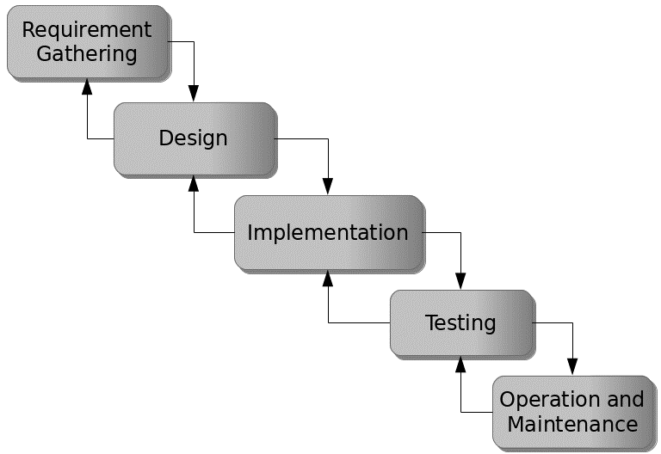

Figure 3.1: Waterfall Model

## 3.5 Method of Data Collection

This study will adopt two methods of data collection are the primary and secondary methods.

## 3.6 System Design

Systems design is the process of defining the architecture, modules, interfaces, and data for a system to satisfy specified requirements. Systems design could be seen as the application of systems theory to product development.

## 3.6.1 Algorithm Diagram

**Use case diagram**

A use case diagram at its simplest is a representation of a user’s interaction with the system and depicting the specifications of a use case.

Registration

Login

Add Employee

View Promotion Request

Add Department

Admin

Staff

Apply for Promotion

Approve/Decline Promotion

Add user

View Report

Print Report

Log out

Figure 3.2: Use Case Diagram

## 3.6.2 System Architecture

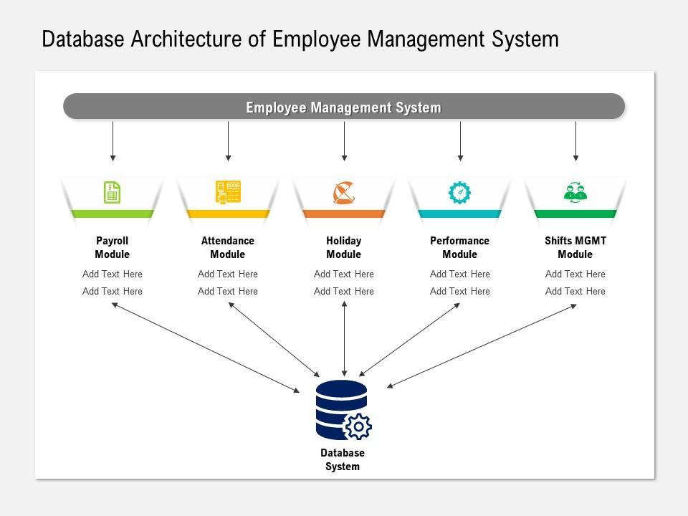

STAFF PROMOTION AND REMUNERATION SYSTEM

Figure 3.3: System Architecture

## 3.6.3 Database Tables/Queries Structures

**Table 3.1: Users Table**

|  |  |  |  |
| --- | --- | --- | --- |
| **Field** | **Datatype (length)** | **Key** | **Extra** |
| id | int(10) | PRIMARY | auto_increment |
| firstname | int(10) | FOREIGN |  |
| middlename | varchar(50) |  |  |
| lastname | varchar(50) |  |  |
| username | varchar(50) |  |  |
| password | varchar(50) |  |  |
| passport | varchar(50) |  |  |
| Level | varchar(50) |  |  |
| type | varchar(50) |  |  |
| Addeddate | varchar(50) |  |  |
| updateddate | varchar(50) |  |  |

**Table 3.2: Departments Table**

|  |  |  |  |  |
| --- | --- | --- | --- | --- |
| **Field** | **Type** | **Key** | **Default** | **Extra** |
| id | int(10) | PRIMARY |  | auto_increment |
| name | Varchar (5) |  |  |  |
| description | Varchar (5) |  |  |  |
| Dated created | timestamp |  |  |  |
| Date updated | timestamp |  | current_timestamp() |  |

**Table 3.3: Designation Table**

|  |  |  |  |  |
| --- | --- | --- | --- | --- |
| **Field** | **Type** | **Key** | **Default** | **Extra** |
| id | int(10) | PRIMARY |  | auto_increment |
| name | Varchar (5) |  |  |  |
| description | Varchar (5) |  |  |  |
| Dated created | timestamp |  |  |  |
| Date updated | timestamp |  | current_timestamp() |  |

**Table 3.4: Promotion Table**

|  |  |  |  |  |
| --- | --- | --- | --- | --- |
| **Field** | **Type** | **Key** | **Default** | **Extra** |
| id | int(10) | PRI |  | auto_increment |
| userid | varchar(20) |  |  |  |
| reason | varchar(50) |  |  |  |
| Current level | varchar(50) |  |  |  |
| Level | varchar(50) |  |  |  |
| salary | varchar(50) |  |  |  |
| date | timestamp |  |  |  |

## 3.6.4 Database Entity Relationship Diagram

This shows the relationship of the various tables in the database with each other

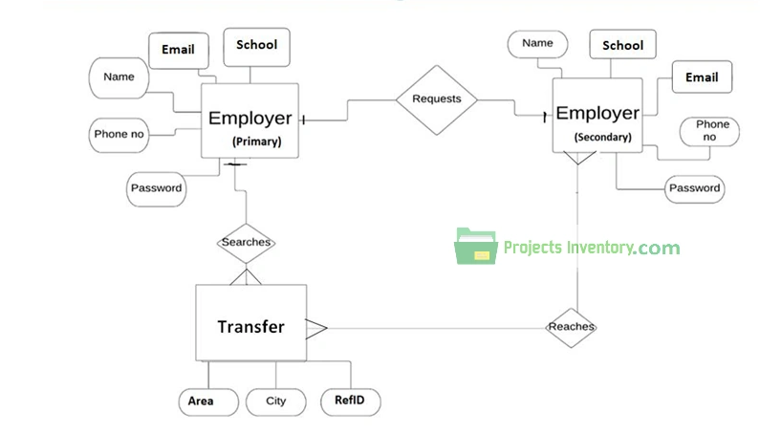

**Promotion**

**Level**

**Salary**

**Staffid**

Figure 3.4: Database Entity Relationship Diagram

## 3.6.5 The Input and Output Design

Username/Email Address

Enter Password

#### Don't Have an Account? [Create Account](http://localhost/school_dev/app.php#demanppopUpWindow)

Login

Figure 3.5: Login interface

**REGISTRATION FORM**

Employee ID

First Name

Middle Name

Last Name

Date of Birth

Department

Designation

Current Level

Email

Address

Phone number

Passport

**SAVE**

**CANCEL**

Figure 3.6: Registration Interface

**APPLY FOR PROMOTION**

Select Employee

Promotion Level

Remark

**SAVE**

**CANCEL**

Figure 3.7: Apply for Promotion Interface

**NEW DEPARTMENT**

Name

Remark

**SAVE**

**CANCEL**

Figure 3.8: Add Department

**CREATE LEVEL**

Code

Name

Decription

Status

Salary

**SAVE**

**CANCEL**

Figure 3.9: Add Level

## 3.7 System Requirement Specification

## 3.7.1 Hardware Requirements

The software designed needed the following hardware for an effective operation of the newly designed system.

1. A system running on intel, P(R) duo core with higher processor
2. The-Random Access Memory (RAM) should be at least 512mb.
3. Enhanced keyboard.
4. At least 20-GB hard disk.
5. V.G.A or a colored monitor.

## 3.7.2 Software Requirements

The software requirements include:

1. A window 7 or higher version of operating system.
2. XAMP or WAMP for Database
3. PHP

## 3.7.3 Personnel Requirements

Any computer literate who has a technical knowhow of internet surfing can use the system because it is user friendly.

# CHAPTER FOUR

# RESULTS AND DISCUSSION

## 4.1 Introduction

The new system is designed using PHP and MySQL programming language for easy records inserting and updating. This system will help in managing and easily retrieving of information from the system for management purposes. The new system a Model Architecture for Staff Promotion and Remuneration.

## 4.2 Results

## 4.2.1 Welcome Interface



Figure 4.2.1: Welcome Interface

The above figure 4.2.1 shows the welcome page of the Staff Promotion and Remuneration system, the welcome page is the first page that displays on opening the program.

## 4.2.2 Login Interface



Figure 4.2.2: Login page interface

Figure 4.2.2 above shows the system login page interface. The login interface allows the users and Administrator to enter his username and password to get access to the system.

## 4.2.3 Registration Interface

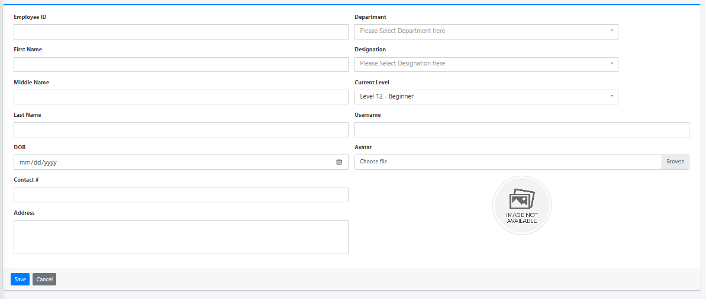

Figure 4.2.3: Registration Interface

Figure 4.2.3 above shows where users can register to gain access into the system using some basic information like the student first name, lastname, othername, level.

## 4.2.4 Apply for Promotion

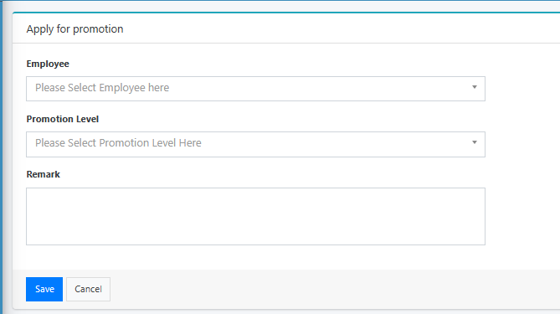

Figure 4.2.4: Apply for Promotion Interface

Figure 4.2.4 is used to make result for a promotion by an employee from a current level to another level, which will involve an increase in salary.

## 4.2.5 Promotion Request

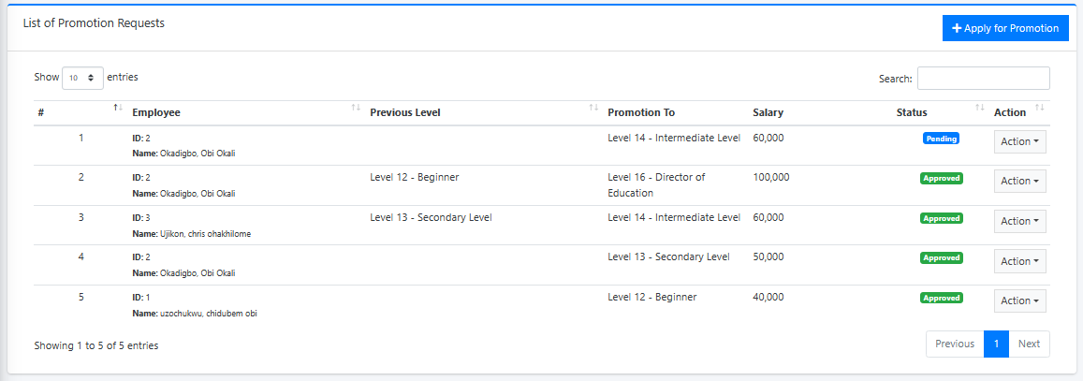

Figure 4.2.5: Promotion Request Interface

Figure 4.2.5 above displays all the promotion requests both denied, pending, approved or cancelled promotion requests.

## 4.2.6 Create New Department

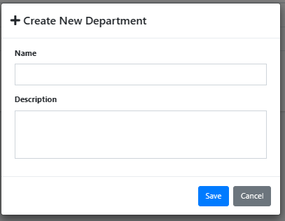

Figure 4.2.6: Create New Department

Figure 4.2.6 above is used to create or add department into the system.

## 4.2.7 Create New Level

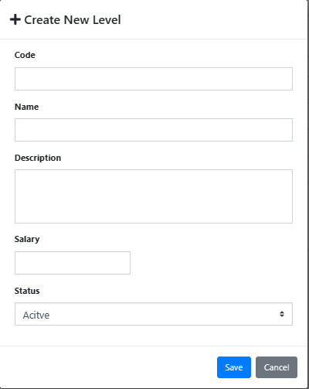

Figure 4.2.7: Create Level Interface

Figure 4.2.7 above is used to create a new promotion level by the admin which will be used when registering or promoting a staff.

## 4.2.8 Dashboard Interface

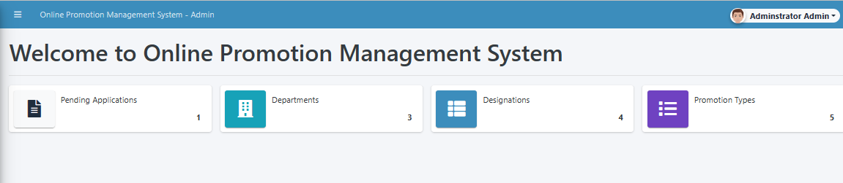

Figure 4.2.8: Dashboard Interface

Figure 4.2.8 above shows all the activities and functions that the admin can perform on the system. It also shows a summary of all employees and promotion requests.

## 4.3 Discussion

The Welcome Interface is the initial landing page of the website. It is designed to create a positive first impression on visitors. This interface typically includes a visually appealing layout, branding elements, and possibly a brief introduction to the website's purpose or features. The goal is to engage users and encourage them to explore further.

The Login Interface is where registered users can log into their accounts using their credentials. It includes fields for entering a username/email and password. This interface may also include options for password recovery or account registration for new users who haven't signed up yet.

The Registration Interface allows new users to create accounts on the website. Users typically provide their personal information, such as name, email, and password. It may include validation checks to ensure the accuracy of provided data.

The Apply for Promotion Interface enables eligible employees to apply for promotions within the organization. It might include a form where employees can provide details about their current position, achievements, and reasons for seeking a promotion.

The Promotion Request Interface is where managers or administrators review and process employee promotion requests. It allows them to view employee details, assess eligibility, and make decisions regarding promotions.

The Create New Department Interface is used by administrators or authorized personnel to add new departments to the organization's structure. It may involve providing department name, description, and assigning relevant managers.

The Create New Level Interface allows administrators to add new hierarchical levels or designations within the organization. This could involve specifying the level name, role description, and potential reporting relationships.

The Dashboard Interface serves as a central hub where users can access key information and perform various tasks. It provides an overview of important data, metrics, and activities related to the user's role or responsibilities. Dashboards often include charts, graphs, notifications, and links to other sections of the website.

Each of these interfaces contributes to the functionality and user experience of the website, serving specific purposes and enabling users to interact with the platform in meaningful ways.

## 4.4 User manual

The following are the necessary steps to take in order to use the system efficiently and effectively.

1. Load the url of the system <https://localhost/promotion/> the welcome page will be displayed.
2. Click on the **Proceed** button to proceed to the main system.
3. If you created an account, provide your login details by entering your username and password.
4. Depending on the login details provided you will be automatically directed to the dashboard.
5. The various task that you can perform on the portal will be displayed on the sidebar of the dashboard.

# CHAPTER FIVE

# SUMMARY, CONCLUSION AND RECOMMENDATIONS

## 5.1 Summary

The design and implementation of a model architecture for staff promotion and remuneration system represent a significant advancement in optimizing human resource management within organizations. This study aimed to address the challenges associated with manual and subjective promotion and remuneration processes. By leveraging technology and data-driven insights, the proposed model architecture offers a streamlined, transparent, and efficient approach.

## 5.2 Conclusion

In conclusion, the successful design and implementation of the model architecture demonstrate its potential to revolutionize staff promotion and remuneration management. The system's automation, standardized criteria, and data utilization contribute to enhanced fairness, accuracy, and accountability. The positive outcomes observed in the practical implementation underscore its value as a transformative tool for organizational growth and employee satisfaction.

## 5.3 Recommendations

Based on the findings and outcomes of this study, several recommendations are put forth.

1. It is recommended that organizations should consider adopting the model architecture to modernize their promotion and remuneration processes.
2. Also, ongoing training and support for users of the system are crucial to maximize its benefits.
3. Continuous monitoring and evaluation are recommended to ensure the system's effectiveness and relevance over time.

## 5.4 Contribution to Knowledge

This study significantly contributes to the knowledge and understanding of staff promotion and remuneration management. The model architecture provides a structured framework that aligns with best practices, leveraging technology for improved decision-making and equitable outcomes. The insights gained from the implementation process offer valuable lessons for future research and practical applications in the field of human resource management.

## 5.5 Area for Further Work

While the current study has successfully introduced and implemented the model architecture, there are opportunities for further research and development. Future work could focus on refining the system's algorithms, expanding its functionalities, and exploring its adaptability to diverse organizational contexts. Additionally, investigating the long-term impact of the model architecture on employee motivation, retention, and organizational performance would provide valuable insights.

**REFERENCES**

Adams, K. (2022). The Role of Automation in Educational Financial Management. *Journal of Information Technology in Education,* 15(3), 120-135.

Aguinis, K., & Kraiger, J. (2022). The Impact of Payment Systems on Error Reduction in Educational Institutions. *International Journal of Educational Finance,* 20(1), 56-70.

Allen, D. & James, M. (2021). Retaining Talent: The Relationship between Rewards, Engagement, and Turnover. *Journal of Management,* 46(8), 1300-1328.

Allen, D. G., Bryant, P. C., & Vardaman, J. M. (2021). Retaining Talent: The Relationship between Rewards, Engagement, and Turnover. *Journal of Management,* 46(8), 1300-1328.

Anderson, L., & Schalk, S. (2018). Ensuring Data Security in Payment Systems for Educational Institutions. *International Journal of Cybersecurity*, 18(1), 45-60.

Armstrong, M. (2019). *Armstrong's Handbook of Human Resource Management Practice*. Kogan Page Publishers.

Bendl, Y. (2021). Application of Predictive Modeling in Education: A Review. *Journal of Computers in Education,* 8(1), 19-37.

Cable, S. M., & Judge, A. (2016). Success Factors and Barriers of Adopting the Automated System of Student Affairs in Saudi Universities. *International Journal of Higher Education,* 8(3), 1-9.

Denisi, U. & Kluger, W. (2020). Mobile Property Management Systems: A Study of Design and Implementation. *Information Systems Frontiers*, 1-14.

Elmasri, R., & Navathe, S. B. (2019). *Fundamentals of Database Systems.* Pearson, New York.

Ghazal, O., Ionita, H. & Gorges, O. (2020). An Artificial Intelligence Platform for Property Management: *A Conceptual Model. Computers in Industry*, 125, 103-379.

Goblar, N. (2022). Decision Support System in Higher Education: A Case Study of an Adaptive Learning Management System. *Journal of Computers in Education,* 8(2), 215-239.

Illmakunnas, H. (2023). Adoption of E-payment Systems in Higher Education: A Comparative Study*. International Journal of Educational Technology*, 14(3), 57-72.

Jagero, R., & Kangethe, A. (2020). The Importance of Financial Transparency in Educational Institutions. *Journal of Education Finance and Policy,* 25(2), 89-104.

Jurban, L., Turner, R., & Gonzalez, E. (2023). Improving Financial Management in Universities with Payment Systems. *Journal of Higher Education Management,* 16(2), 78-92.

Kalesh, S. & Tuwei, J. (2022). Web-based Rental Property Management System for Efficient and Effective Property Management. *Journal of Engineering Technology*, 18(1), 221-229.

Kapoor, A., & Singh, P. (2020). Digital Transformation in Compensation and Benefits Management. *International Journal of Recent Technology and Engineering*, 9(2), 6742-6746.

Lazear, S., & Rosen, M. (2023). Student Perspectives on Payment Systems in Higher Education. *International Journal of Educational Technology*, 15(1), 34-48.

Liu, K., Letchkov, N., Koychev, I., & Ivanov, B. (2020). Cloud-Based Property Management Systems. *In Proceedings of the International Conference on Advances in Business, Management and Law*, 7(1), 169-177.

Mahmud, N. (2020). Evaluation of Records Management Systems in Public Universities in Kenya. *International Journal of Information Systems and Project Management,* 8(3), 43-62.

Martins, A., Proença, T., & Gonçalves, R. (2020). Employee Compensation, Incentives, and Innovation. *Research in Human Resource Management (RHRM),* 12(1), 45-54.

Mathe, U., Lee, L., Ming, I., & Hashim, L. (2021). The Role of Management Information Systems in Data Analytics: A Strategic Perspective on Global Business Environments. *Information Systems Frontiers,* 22(4), 909-924.

Motahari-Nezhad, H. R., Stephenson, B., Shahbazian, M., & Foster, H. (2021). Database Management Systems. *In Handbook on Securing Cyber-Physical Critical Infrastructure* (pp. 195-217). Springer.

Olivera, M. & Martins, L. (2021). The Adoption of Property Management Systems in the Real Estate Sector. *Journal of Business and Management*, 23(2), 71-92.

Poon, J. M. (2019). The Impact of Non-Financial Rewards on Employee Engagement and Retention. *Employee Relations*, 41(2), 333-348.

Rahman, L., Huang, O., Tim, R. & Gehrke, J. (2020). *Database Management Systems*. McGraw-Hill.

Ramakrishnan, M. & Gehrke, M. (2020). An Integrated Framework for E-Records Management System (ERMS) Development: A Study on Bangladesh Government Sector. *International Journal of Electronic Government Research*, 16(3), 19-38.

Reddy, B. S., & Kumar, G. P. (2021). Personalized Compensation and Benefits: A New Paradigm. *International Journal of Applied Engineering Research*, 16(1), 69-73.

Rizvi, S., Khan, M. A., Bhatti, R. A., & Ziauddin, Z. (2021). A Comparative Study of Database Management Systems. *Journal of Information Systems and Technology Management*, 18, 202-1134.

Shore, F. (2019). A Model for Developing a Student Management System (SMS) in Saudi Universities. *Journal of Educational Computing Research,* 58(3), 523-552.

Singhal, J. (2021). Digital Transformation in Higher Education: Advancements and Challenges. *International Journal of Educational Technology,* 12(4), 65-79.

Tziner, J. & Vardi, K. (2018). Cloud-Based Property Management System with Mobile Integration for Small and Medium-Sized Landlords. *Journal of Systems and Information Technology*, 23(3), 486-503.

Vroom Q. (2017). A Framework for Smart Rental Property Management. *IEEE Access*, 8, 134127-134139.

Wasana, A. (2020). Design and Development of Mobile Applications for Property Management. *International Journal of Information Systems and Project Management,* 9(2), 5-19.

Wayne, K. (2022). Digitalizing Student Fee Management: Challenges and Opportunities. *Journal of Educational Administration,* 46(1), 89-105.

Welch, M., & Jackson, S. E. (2017). Rethinking Diversity in Research on Organizations: Toward a Structural Perspective. *Research in Organizational Behavior*, 27, 3-30.

Wu, L., & Zhu, C. (2021). Security Considerations in Designing University Payment Systems. *Journal of Information Security,* 35(2), 213-228.

# APPENDIX A

## Welcome Interface



**Registration Interface**



## Dashboard Interface



## Apply for Promotion



## Login Interface



## Promotion Request



## Create New Department



## Create New Level



# APPENDIX B

**PROGRAM CODE**

<?php require_once('config.php'); ?>

<!DOCTYPE html>

<html lang="en">

<?php require_once('inc/header.php') ?>

<body>

<?php $page = isset($_GET['p']) ? $_GET['p'] : 'home';  ?>

<?php

    if(!file_exists($page.".php") && !is_dir($page)){

        include '404.html';

    }else{

    if(is_dir($page))

        include $page.'/index.php';

    else

        include $page.'.php';

    }

?>

<?php require_once('inc/footer.php') ?>

<div class="modal fade" id="confirm_modal" role='dialog'>

    <div class="modal-dialog modal-md modal-dialog-centered" role="document">

      <div class="modal-content">

        <div class="modal-header">

        <h5 class="modal-title">Confirmation</h5>

      </div>

      <div class="modal-body">

        <div id="delete_content"></div>

      </div>

      <div class="modal-footer">

        <button type="button" class="btn btn-primary" id='confirm' onclick="">Continue</button>

        <button type="button" class="btn btn-secondary" data-dismiss="modal">Close</button>

      </div>

      </div>

    </div>

  </div>

  <div class="modal fade" id="uni_modal" role='dialog'>

    <div class="modal-dialog   rounded-0 modal-md modal-dialog-centered" role="document">

      <div class="modal-content  rounded-0">

        <div class="modal-header">

        <h5 class="modal-title"></h5>

      </div>

      <div class="modal-body">

      </div>

      <div class="modal-footer">

        <button type="button" class="btn btn-primary" id='submit' onclick="$('#uni_modal form').submit()">Save</button>

        <button type="button" class="btn btn-secondary" data-dismiss="modal">Cancel</button>

      </div>

      </div>

    </div>

  </div>

  <div class="modal fade" id="uni_modal_right" role='dialog'>

    <div class="modal-dialog  rounded-0 modal-full-height  modal-md" role="document">

      <div class="modal-content rounded-0">

        <div class="modal-header">

        <h5 class="modal-title"></h5>

        <button type="button" class="close" data-dismiss="modal" aria-label="Close">

          <span class="fa fa-arrow-right"></span>

        </button>

      </div>

      <div class="modal-body">

      </div>

      </div>

    </div>

  </div>

  <div class="modal fade" id="viewer_modal" role='dialog'>

    <div class="modal-dialog modal-md" role="document">

      <div class="modal-content">

              <button type="button" class="btn-close" data-dismiss="modal"><span class="fa fa-times"></span></button>

              <img src="" alt="">

      </div>

    </div>

  </div>

</body>

</html>

<h1>Welcome to <?php echo $_settings->info('name') ?></h1>

<hr class="bg-light">

<?php if($_settings->userdata('type') != 3): ?>

<div class="row">

          <div class="col-12 col-sm-6 col-md-3">

            <div class="info-box">

              <span class="info-box-icon bg-light elevation-1"><i class="fas fa-file-alt"></i></span>

              <div class="info-box-content">

                <span class="info-box-text">Pending Applications</span>

                <span class="info-box-number text-right">

                  <?php

                    $pending = $conn->query("SELECT * FROM `leave_applications` where date_format(date_start,'%Y') = '".date('Y')."' and date_format(date_end,'%Y') = '".date('Y')."' and status = 0 ")->num_rows;

                    echo number_format($pending);

                  ?>

                  <?php ?>

                </span>

              </div>

              <!-- /.info-box-content -->

            </div>

            <!-- /.info-box -->

          </div>

          <!-- /.col -->

          <div class="col-12 col-sm-6 col-md-3">

            <div class="info-box mb-3">

              <span class="info-box-icon bg-info elevation-1"><i class="fas fa-building"></i></span>

              <div class="info-box-content">

                <span class="info-box-text"> Departments</span>

                <span class="info-box-number text-right">

                  <?php

                    $department = $conn->query("SELECT id FROM `department_list` ")->num_rows;

                    echo number_format($department);

                  ?>

                </span>

              </div>

              <!-- /.info-box-content -->

            </div>

            <!-- /.info-box -->

          </div>

          <!-- /.col -->

          <!-- fix for small devices only -->

          <div class="clearfix hidden-md-up"></div>

          <div class="col-12 col-sm-6 col-md-3">

            <div class="info-box mb-3">

              <span class="info-box-icon bg-lightblue elevation-1"><i class="fas fa-th-list"></i></span>

              <div class="info-box-content">

                <span class="info-box-text"> Designations</span>

                <span class="info-box-number text-right">

                <?php

                    $designation = $conn->query("SELECT id FROM `designation_list`")->num_rows;

                    echo number_format($designation);

                  ?>

                </span>

              </div>

              <!-- /.info-box-content -->

            </div>

            <!-- /.info-box -->

          </div>

          <div class="col-12 col-sm-6 col-md-3">

            <div class="info-box mb-3">

              <span class="info-box-icon bg-purple elevation-1"><i class="fas fa-list"></i></span>

              <div class="info-box-content">

                <span class="info-box-text">Promotion Types</span>

                <span class="info-box-number text-right">

                <?php

                    $leave_types = $conn->query("SELECT id FROM `leave_types` where status = 1 ")->num_rows;

                    echo number_format($leave_types);

                  ?>

                </span>

              </div>

              <!-- /.info-box-content -->

            </div>

            <!-- /.info-box -->

          </div>

        </div>

<?php else: ?>

  <div class="row">

    <div class="col-12 col-sm-6 col-md-3">

      <div class="info-box">

        <span class="info-box-icon bg-light elevation-1"><i class="fas fa-file-alt"></i></span>

        <div class="info-box-content">

          <span class="info-box-text">Pending Applications</span>

          <span class="info-box-number text-right">

            <?php

              $pending = $conn->query("SELECT * FROM `leave_applications` where date_format(date_start,'%Y') = '".date('Y')."' and date_format(date_end,'%Y') = '".date('Y')."' and status = 0 and user_id = '{$_settings->userdata('id')}' ")->num_rows;

              echo number_format($pending);

            ?>

            <?php ?>

          </span>

        </div>

        <!-- /.info-box-content -->

      </div>

      <!-- /.info-box -->

    </div>

    <div class="col-12 col-sm-6 col-md-3">

      <div class="info-box">

        <span class="info-box-icon bg-lightblue elevation-1"><i class="fas fa-th-list"></i></span>

        <div class="info-box-content">

          <span class="info-box-text">Promotion Requests</span>

          <span class="info-box-number text-right">

            <?php

              $upcoming = $conn->query("SELECT * FROM `leave_applications` where date(date_start) > '".date('Y-m-d')."' and status = 1 and user_id = '{$_settings->userdata('id')}' ")->num_rows;

              echo number_format($upcoming);

            ?>

            <?php ?>

          </span>

        </div>

        <!-- /.info-box-content -->

      </div>

      <!-- /.info-box -->

    </div>

  </div>

<?php endif; ?>